Sharing the love of   
Jesus in the UW   
campus community.

**Calvary   
Lutheran   
Chapel**UW-Madison

Sunday, September 27, 2020

*Seventeenth Sunday After Pentecost*



Lutheran Church—Missouri Synod

701 State Street, Madison, WI, 53703

608.255.7214

Pastor Dan Anderson: dan@calvarymadison.org

IFC Director Judy Tang: [ifc@ifcmadison.org](mailto:ifc@ifcmadison.org)­

Music Director Josh Vaughn: josh@calvarymadison.org

Admin Asst. Joan Ostrowsky: joan@calvarymadison.org

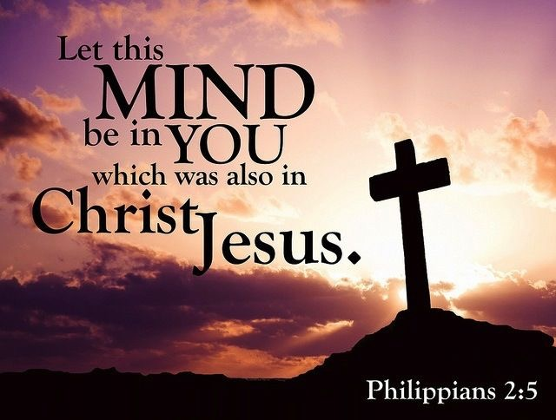

Board of Directors President: Rebekah Janssen

(rejanssen@wisc.edu)

Board of Spiritual Life Chairman: Bryan Boger

(boger.bryan@gmail.com)

Leadership Team President: Deseree Dufek

([desereedufek@gmail.com](mailto:desereedufek@gmail.com))

**PD WILL BE POSTING SUNDAY MORNING AND WEDNESDAY EVENING SERVICES ON FACEBOOK LIVE!**

**BELOW IS THE LINK TO OUR FACEBOOK PAGE.**

**GO THERE AND “LIKE” THE PAGE AND THEN TUNE IN @ 11:00 AM ON SUNDAYS AND @ 7:00 PM ON WEDNESDAYS!**

[**https://www.facebook.com/CalvaryLutheranChapel/**](https://www.facebook.com/CalvaryLutheranChapel/%20)

**AS WE GATHER**

It has become commonplace to speak of God as responsible for determining life and death for us. So we wonder where is God’s justice when the innocent suffer or His mercy when tragedy strikes. But the Lord insists He has no pleasure in the death of anyone—not even the sinner who deserves his punishment. God’s good and gracious will is that all would be saved and come to the knowledge of His Son. Think how differently we would approach the troubles and trials that affect us and the greater disasters of the world if we took the Lord at His Word and trusted in His will.

*\*Prayer Requests:*

We invite you to email any prayer requests you have to Pastor Dan and he will include them in next week’s service.

**WELCOME**

**OPENING HYMN** (vv. 1-6)

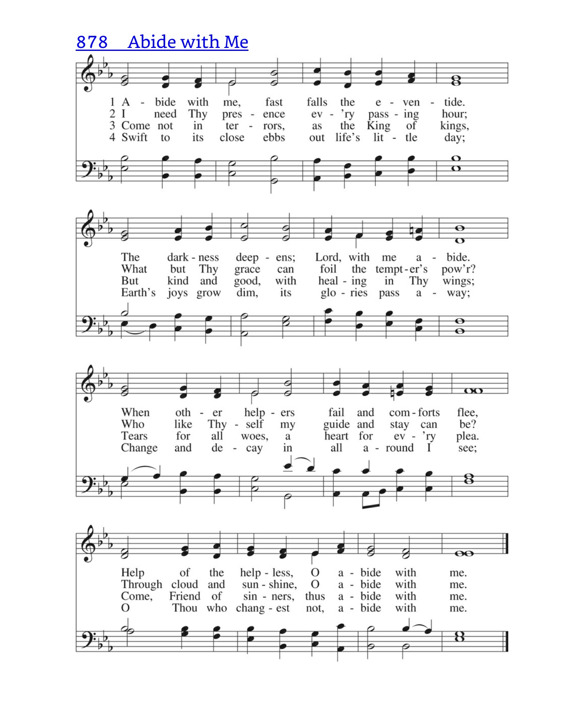

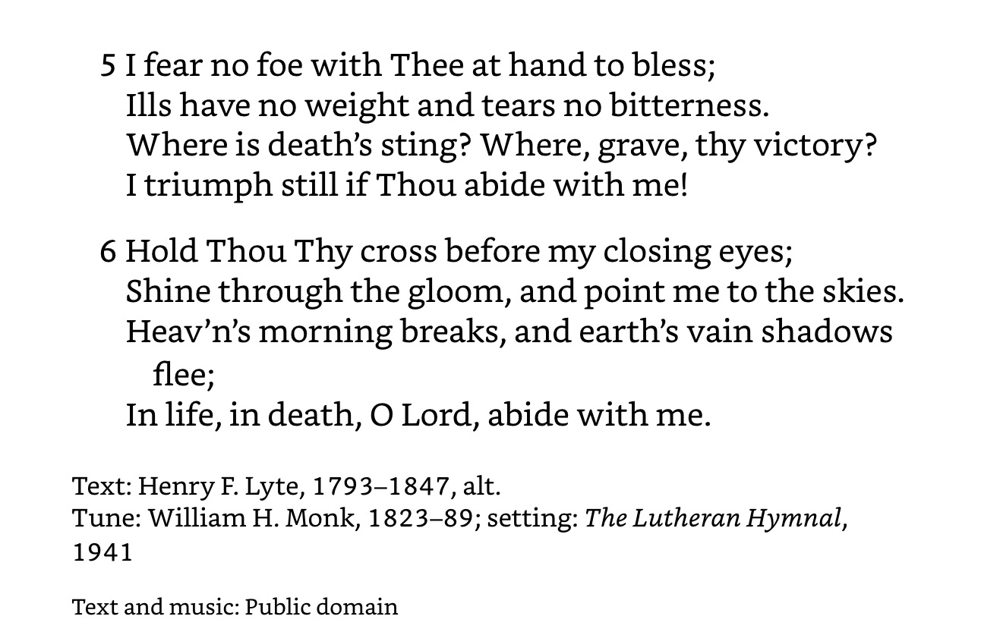

*(Congregation stands)*

**INVOCATION**

Pastor: In the name of the Father and of the ✠ Son and of the Holy Spirit.

**People: Amen.**

**OPENING SENTENCES** *Psalm 25:6–7; 147:6*

Pastor: The Lord lifts up the humble;

**People: He casts the wicked to the ground.**

Pastor: Remember Your mercy, O Lord, and Your steadfast love

**People: for they have been from of old.**

Pastor: Remember not the sins of my youth or my transgressions;

**People: according to Your steadfast love, remember me, for the sake of Your goodness, O Lord!**

**CONFESSION AND ABSOLUTION**

Pastor: O almighty God, merciful Father,

**People: I, a poor, miserable sinner, confess unto You all my sins and iniquities with which I have ever offended You and justly deserved Your temporal and eternal punishment. But I am heartily sorry for them and sincerely repent of them, and I pray You of Your boundless mercy and for the sake of the holy, innocent, bitter sufferings and death of Your beloved Son, Jesus Christ, to be gracious and merciful to me, a poor, sinful being.**

Pastor: Upon this your confession, I, by virtue of my office, as a called and ordained servant of the Word, announce the grace of God unto all of you, and in the stead and by the command of my Lord Jesus Christ I forgive you all your sins in the name of the Father and of the ✠ Son and of the Holy Spirit.

**People: Amen.**

Pastor: May the Lord, who has begun this good work in us, bring it to completion in the day of our Lord Jesus Christ. The peace of the Lord be with you.

**People: And also with you.**

*The congregation exchanges the peace of the Lord.*

**INTROIT** *Psalm 147:1–5; antiphon v. 6*

Pastor: Praise the Lord! For it is good to sing praises to our God; for it is pleasant, and a song of praise is fitting.

**People: The Lord lifts up the humble; he casts the wicked to the ground.**

Pastor: The Lord builds up Jerusalem; he gathers the outcasts of Israel.

**People: The Lord lifts up the humble; he casts the wicked to the ground.**

Pastor: He heals the brokenhearted and binds up their wounds.

**People: The Lord lifts up the humble; he casts the wicked to the ground.**

Pastor: He determines the number of the stars; he gives to all of them their names.

**People: The Lord lifts up the humble; he casts the wicked to the ground.**

Pastor: Great is our Lord, and abundant in power; his understanding is beyond measure.

**People: The Lord lifts up the humble; he casts the wicked to the ground.**

**HYMN OF PRAISE**

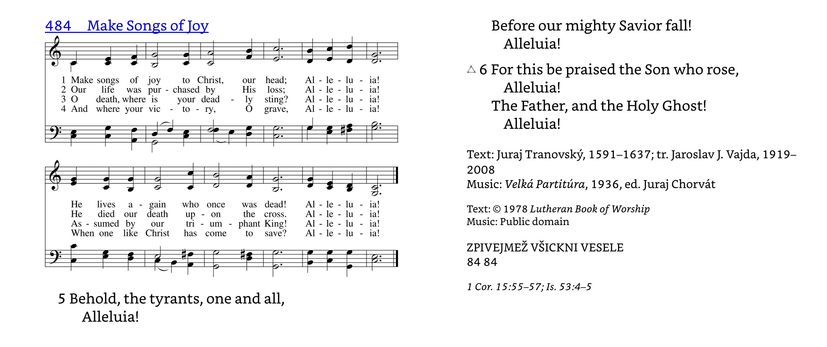

**SALUTATION**

Pastor: The Lord be with you.

**People: And also with you.**

**PRAYER OF THE DAY**

Pastor: Let us pray.  
O God of life and hope, You have given rescue to sinners in despair of their sins and to those marked for death. Turn our attention to Your mercy that we learn to rejoice in Your good will, that all would be saved and come to the knowledge of Christ our Savior; through Jesus Christ, our Lord, who lives and reigns with You and the Holy Spirit, one God, now and forever.

**People: Amen.**

*(Congregation is seated)*

**OLD TESTAMENT READING** *Ezekiel 18:1–4, 25–32*

The word of the Lord came to me: **2**“What do you mean by repeating this proverb concerning the land of Israel, ‘The fathers have eaten sour grapes, and the children's teeth are set on edge’? **3**As I live, declares the Lord God, this proverb shall no more be used by you in Israel.  **4**Behold, all souls are mine; the soul of the father as well as the soul of the son is mine: the soul who sins shall die.

**25**“Yet you say, ‘The way of the Lord is not just.’ Hear now, O house of Israel: Is my way not just? Is it not your ways that are not just? **26**When a righteous person turns away from his righteousness and does injustice, he shall die for it; for the injustice that he has done he shall die. **27**Again, when a wicked person turns away from the wickedness he has committed and does what is just and right, he shall save his life. **28**Because he considered and turned away from all the transgressions that he had committed, he shall surely live; he shall not die. **29**Yet the house of Israel says, ‘The way of the Lord is not just.’ O house of Israel, are my ways not just? Is it not your ways that are not just? **30**“Therefore I will judge you, O house of Israel, every one according to his ways, declares the Lord God. Repent and turn from all your transgressions, lest iniquity be your ruin. **31**Cast away from you all the transgressions that you have committed, and make yourselves a new heart and a new spirit! Why will you die, O house of Israel? **32**For I have no pleasure in the death of anyone, declares the Lord God; so turn, and live.”

Lector: This is the Word of the Lord.

**People: Thanks be to God.**

**PSALM** *Psalm 25:1–10 (Psalm Tone A)*

Pastor: To you, ǀ O LORD,*

I lift ǀ up my soul.

**People: O my God, in you I trust; let me not be ǀ put to shame;\***

**Let not my enemies exult ǀ over me.**

Pastor: Indeed, none who wait for you shall be ǀ put to shame;*

They shall be ashamed who are wantonly ǀ treacherous.

**People: Make me to know your ways, ǀ O LORD;\***

**Teach me ǀ your paths.**

Pastor: Lead me in our truth and teach me, for you are the God of my sal- ǀ vation;*

For you I wait all the ǀ day long.

**People: Remember your mercy, O LORD, and your ǀ steadfast love,\***

**For they have been ǀ from of old.**

Pastor: Remember not the sins of my youth or my trans- ǀ gressions;*

According to your steadfast love remember me, for the sake of your goodness, ǀ O LORD!

**People: Good and upright ǀ is the LORD;\***

**Therefore he instructs sinners ǀ in the way.**

Pastor: He leads the humble in ǀ what is right,*

And teaches the humble ǀ his way.

**People: All the paths of the LORD are steadfast love and ǀ faithfulness,\***

**For those who keep his covenant and his testi- ǀ monies.**

**All: Glory be to the Father and ǀ to the Son\***

**and to the Holy ǀ Spirit;**

**as it was in the be- ǀ ginning,\***

**is now, and will be forever. ǀ Amen.**

**Gradual** *Psalm 91:11; 103:1*

He will command His angels concerning you  
 to guard you in all your ways.  
Bless the Lord, O my soul,  
 and all that is within me, bless His holy name!

**EPISTLE** *Philippians 2:1–18*

So if there is any encouragement in Christ, any comfort from love, any participation in the Spirit, any affection and sympathy, **2**complete my joy by being of the same mind, having the same love, being in full accord and of one mind. **3**Do nothing from selfish ambition or conceit, but in humility count others more significant than yourselves. **4**Let each of you look not only to his own interests, but also to the interests of others. **5**Have this mind among yourselves, which is yours in Christ Jesus, **6**who, though he was in the form of God, did not count equality with God a thing to be grasped, **7**but emptied himself, by taking the form of a servant, being born in the likeness of men. **8**And being found in human form, he humbled himself by becoming obedient to the point of death, even death on a cross. **9**Therefore God has highly exalted him and bestowed on him the name that is above every name, **10**so that at the name of Jesus every knee should bow, in heaven and on earth and under the earth, **11**and every tongue confess that Jesus Christ is Lord, to the glory of God the Father. **12**Therefore, my beloved, as you have always obeyed, so now, not only as in my presence but much more in my absence, work out your own salvation with fear and trembling, **13**for it is God who works in you, both to will and to work for his good pleasure. **14**Do all things without grumbling or disputing, **15**that you may be blameless and innocent, children of God without blemish in the midst of a crooked and twisted generation, among whom you shine as lights in the world, **16**holding fast to the word of life, so that in the day of Christ I may be proud that I did not run in vain or labor in vain. **17**Even if I am to be poured out as a drink offering upon the sacrificial offering of your faith, I am glad and rejoice with you all. **18**Likewise you also should be glad and rejoice with me.

Lector: This is the Word of the Lord.

**People: Thanks be to God.**

**VERSE** *Matthew 28:18b*

Alleluia. All authority in heaven and on earth has been given to Me. Alleluia.

*(Congregation stands)*

**HOLY GOSPEL**  *Matthew 21:23–32*

Pastor: The Holy Gospel according to St. Matthew, the twenty-first chapter.

**People: Glory to You, O Lord.**

**23**And when he entered the temple, the chief priests and the elders of the people came up to him as he was teaching, and said, “By what authority are you doing these things, and who gave you this authority?” **24**Jesus answered them, “I also will ask you one question, and if you tell me the answer, then I also will tell you by what authority I do these things. **25**The baptism of John, from where did it come? From heaven or from man?” And they discussed it among themselves, saying, “If we say, ‘From heaven,’ he will say to us, ‘Why then did you not believe him?’ **26**But if we say, ‘From man,’ we are afraid of the crowd, for they all hold that John was a prophet.” **27**So they answered Jesus, “We do not know.” And he said to them, “Neither will I tell you by what authority I do these things. **28**“What do you think? A man had two sons. And he went to the first and said, ‘Son, go and work in the vineyard today.’ **29**And he answered, ‘I will not,’ but afterward he changed his mind and went. **30**And he went to the other son and said the same. And he answered, ‘I go, sir,’ but did not go. **31**Which of the two did the will of his father?” They said, “The first.” Jesus said to them, “Truly, I say to you, the tax collectors and the prostitutes go into the kingdom of God before you. **32**For John came to you in the way of righteousness, and you did not believe him, but the tax collectors and the prostitutes believed him. And even when you saw it, you did not afterward change your minds and believe him.

Pastor: This is the Gospel of the Lord.

**People: Praise to You, O Christ.**

*(Congregation is seated)*

**SONG OF THE DAY** “King of my Heart”

|  |  |
| --- | --- |
| **Verse 1**  Let the King of my heart  Be the mountain where I run  The fountain I drink from  Oh He is my song  Let the King of my heart  Be the shadow where I hide  The ransom for my life  Oh He is my song  **Chorus**  You are good good oh  You are good good oh  You are good good oh  You are good good oh  **Verse 2**  Let the King of my heart  Be the wind inside my sails  The anchor in the waves  Oh He is my song  Let the King of my heart  Be the fire inside my veins  The echo of my days  Oh He is my song | **(Chorus 2X)**  **Bridge**  You're never gonna let  Never gonna let me down  You're never gonna let  Never gonna let me down  You're never gonna let  Never gonna let me down  You're never gonna let  Never gonna let me down  **(Chorus)**  CCLI Song # 7046145  John Mark McMillan | Sarah McMillan  © Meaux Jeaux Music (Admin. by Capitol CMG Publishing)  Raucous Ruckus Publishing (Admin. by Capitol CMG Publishing)  Sarah McMillan Publishing (Admin. by Watershed Music Group)  For use solely with the SongSelect® Terms of Use. All rights reserved. www.ccli.com  CCLI License # 372249 |

**SERMON** **“The Mind of Christ”**  Pastor Dan

*(Congregation stands)*

**CREED *Nicene Creed***

**People: I believe in one God, the Father Almighty, maker of heaven and earth and of all things visible and invisible.**

**And in one Lord Jesus Christ, the only-begotten Son of God, begotten of His Father before all worlds, God of God, Light of Light, very God of very God, begotten, not made, being of one substance with the Father, by whom all things were made; who for us men and for our salvation came down from heaven and was incarnate by the Holy Spirit of the virgin Mary and was made man; and was crucified also for us under Pontius Pilate. He suffered and was buried. And the third day He rose again according to the Scriptures and ascended into heaven and sits at the right hand of the Father. And He will come again with glory to judge both the living and the dead, whose kingdom will have no end.**

**And I believe in the Holy Spirit, the Lord and giver of life, who proceeds from the Father and the Son, who with the Father and the Son together is worshiped and glorified, who spoke by the prophets. And I believe in one holy Christian and apostolic Church, I acknowledge one Baptism for the remission of sins, and I look for the resurrection of the dead and the life ✠ of the world to come. Amen.**

**PRAYER OF THE CHURCH**

Pastor: As You have promised, Lord, hear Your people when they call, and answer us according to Your mercy.  
Almighty Father, You take no pleasure in the death of anyone. As John the Baptist once called a people to repentance and faith, so raise up voices within Your Church today to call a world to turn from their sins and live through faith in Christ. Lord, in Your mercy,

**People: hear our prayer.**

Pastor: Almighty Father, You have given to us the saving name of Jesus. Continue to bless us with faithful pastors who will preach Jesus Christ and His salvation, and bestow upon us faithful church workers who will serve us in Your name. Bless those now preparing for vocations as pastors, deaconesses, teachers, and all other offices as Your Church has established. Lord, in Your mercy,

**People: hear our prayer.**

Pastor: Almighty Father, You are gracious and merciful without end. Deliver us from a spirit of complaint, and keep us from grumbling at Your call to serve You with all that we are and all that we have. Grant us grace to fulfill our baptismal calling where You have placed us and according to the vocations given to us. Lord, in Your mercy,

**People: hear our prayer.**

Pastor: Almighty Father, Your power continues to uphold all things. Give Your blessing to our president, Congress, governor, and state legislature. Guide all who make, administer, and judge our laws that they be in accord with Your commands and give protection to the unborn, the aged, and the oppressed. Lord, in Your mercy,

**People: hear our prayer.**

Pastor: Almighty Father, You know our enemies and those whose purpose is set against Yours. Give Your blessing to all who defend our nation here and abroad and to all emergency personnel and disaster workers who come to our aid in time of need. Guide the nations in the paths of peace and deliver us from terror and violence. Lord, in Your mercy,

**People: hear our prayer.**

Pastor: Almighty Father, You have given us healing, comfort, and peace in Christ, especially in times of illness, affliction, depression, and sorrow. Hear us on behalf of [*names,* and] all who suffer any need. Grant them grace sufficient to sustain them in their hour of trouble and at last deliver them into the perfect rest of Your eternal presence. Lord, in Your mercy,

**People: hear our prayer.**

Pastor: Almighty Father, Your Son has set His Table among us and given us the privilege of receiving His own body and blood in this Sacrament. Guard us against anything that would keep us from receiving the full benefit of this communion. Bring us at last to that day when division, false teaching, and impenitence will all be overcome and we shall be one before You. Lord, in Your mercy,

**People: hear our prayer.**

Pastor: Almighty Father, You give good gifts to Your people. Keep us from ingratitude and guide us to use the resources entrusted to us for the good of the Kingdom. Accept the tithes and offerings we bring to You this day with the worship of our praise and thanksgiving. Lord, in Your mercy,

**People: hear our prayer.**

Pastor: Almighty Father, You have delivered the saints of old into the perfect rest of Your presence. Keep us in faith that we, too, may be faithful unto death and receive from Your hand the crown of everlasting life. Help us to remember their example and to be encouraged in the struggles of this mortal life by the way You sustained them to the end. Lord, in Your mercy,

**People: hear our prayer.**

Pastor: Into Your hands, O Lord, we commend ourselves and all for whom we pray, trusting in Your mercy through Your Son, Jesus Christ, our Lord.

**People: Amen.**

**OFFERING**

Pastor: Lord, lead us into Your kingdom and teach us to pray:

**LORD’S PRAYER** *Matthew 6:9–13*

**People: Our Father who art in heaven, hallowed be Thy name, Thy kingdom come, Thy will be done on earth as it is in heaven; give us this day our daily bread; and forgive us our trespasses as we forgive those who trespass against us; and lead us not into temptation, but deliver us from evil.**

**For Thine is the kingdom and the power and the glory forever and ever. Amen.**

**PAX DOMINI**

Pastor: The peace of the Lord be with you always.

**People: Amen.**

Pastor: Merciful God, it is Your will and Your good pleasure to bring salvation to all people. Grant to us ears willing to hear and hearts willing to trust in Jesus Christ and in His mighty deliverance from sin and death through His suffering and death. Make us bold instruments of Your Word that we proclaim this Gospel in word and in deed so that those who have not heard may believe and those who have not believed may come to faith and rejoice with us to everlasting life; through Your Son, Jesus Christ, our Lord, who lives and reigns with You and the Holy Spirit, one God, now and forever.

**People: Amen.**

**BENEDICAMUS**

Pastor: Let us bless the Lord.

**People: Thanks be to God.**

**BENEDICTION**

Pastor: The Lord bless you and keep you.

The Lord make His face shine on you and be gracious to you.

The Lord look upon you with favor and ✠ give you peace. *Numbers 6:24–26*

**People: Amen.**

*(Congregation is seated)*

**CLOSING SONG** "Turn Your Eyes Upon Jesus"

|  |  |
| --- | --- |
| **Verse 1**  O soul are you weary and troubled  No light in the darkness you see  There's light for a look at the Savior  And life more abundant and free  **Chorus**  Turn your eyes upon Jesus  Look full in His wonderful face  And the things of earth  Will grow strangely dim  In the light of His glory and grace  **Verse 2**  Through death into life everlasting  He passed and we follow Him there  Over us sin no more hath dominion  For more than conquerors we are | **(Chorus)**  **Verse 3**  His Word shall not fail you He promised  Believe Him and all will be well  Then go to a world that is dying  His perfect salvation to tell  **(Chorus)**  CCLI Song # 15960  Helen H. Lemmel  © Words: Public Domain  Music: Public Domain  For use solely with the SongSelect® Terms of Use. All rights reserved. www.ccli.com  CCLI License # 372249 |

**+ TO GOD ALONE BE ALL GLORY +**

Creative Worship for the Lutheran Parish, Series B, Quarter 2. Copyright © 2017 Concordia Publishing House. All rights reserved. Used by permission.



**UPCOMING EVENTS & INFO:**

**UPCOMING CALVARY ONLINE EVENTS**

All Events, Services and Meetings will be held online through Zoom.

The following is our online schedule:

**New Connection Groups! (Weekly)**

Join us as we study the book of Matthew! By inspiration of the Holy Spirit, Matthew’s account tells us about Jesus Christ, the Son of God, ruler of the universe, and our personal Savior and friend. Study books are available at Calvary during worship hours as well as office hours. Pick any group based on your schedule and join them for a time of fellowship, prayer and discussion. Use the links below to join!

*Group (Abby/Chase)* Sundays @ 6:30pm <https://zoom.us/j/232392501>

*Group (Rebekah et al)* Mondays @ 6:00pm <https://us04web.zoom.us/j/499069953?pwd=doRZcjB5Z01PVnkyMCtsejE5UkdyQT09>

*Group (Anna/Brandon)* Tuesdays @ 8:00pm <https://zoom.us/j/701000689>

*Freshman Group* TBD

**Wednesday Evening Worship**

Join us on Wednesdays @ 7 pm as we focus on the Psalms!

This week’s message is from Psalm 2 - *“My King on Zion”*

**Calvary Retreat & Campout Weekend – October 2nd - 4th**

You are invited to join us at Pastor Dan & Holly’s secluded property “Piney Oaks” up north in Mt. Morris. There are opportunities for hiking, biking & boating along with plenty of space to enjoy some down-time around the fire pits (there are 2 of them). There will be plenty of time for fellowship, relaxation and Bible Study. If you are interested, please contact PD at dan@calvarymadison.org to get more information and to sign up for this event!

**Freshman Dinner on State – NEW DATE!**

Thursday, October 8, 6pm – 8pm

New Freshman! Come join us for the Freshman Dinner on State on 10/8!

We will meet at Calvary @ 6 pm.

Calvary will pick up the tab!

**IFC Classes**

The International Friendship Center (IFC) is "zooming" forward by continuing English classes and Bible studies online. Through these classes we are even connecting with students who have returned to their home countries but want to continue to learn and reunite with IFC volunteers! Praise God for the ways in which He is working during this time! If you would like to participate in the classes or help an international by meeting one-on-one for conversation practice, please let Judy know. Judy Tang, IFC Director at Calvary -- [ifc@ifcmadison.org](mailto:ifc@ifcmadison.org).

**Calvary is Looking for House Fellows for Fall 2021**

Contact PD for more info.

**Calvary Offices Will be Open to Meet with PD**

Calvary Offices are now open for those wanting to meet with PD.

Fall Office Hours: Mondays, Tuesdays & Thursdays 10am-4pm, and Wednesdays noon-6pm.

**PASTORAL SUPPORT**

PD will still be available for any pastoral support as needed. If you need anything, please contact PD ([dan@calvarymadison.org](mailto:dan@calvarymadison.org)) (608-215-9526)

**COMPLIANCE WITH MADISON & DANE COUNTY PUBLIC HEALTH EMERGENCY ORDER #8**

As it is stated in Order #8 that every individual age 5 and older must wear a face covering that covers their nose & mouth when in any enclosed building, we ask that you wear a face mask while visiting Calvary. We will be purchasing face masks to have on hand in order to help everyone stay in compliance. Thank you for your cooperation!

**BLESS CALVARY WHEN YOU SHOP!**

Calvary can be a beneficiary of Amazon Smile, which is an offshoot of Amazon that gives a portion of each purchase to a designated beneficiary. You can make Calvary a beneficiary by shopping on [smile.amazon.com](http://smile.amazon.com/). Calvary can be selected for the recipient of the donations. This is a great way for Calvary to generate a little more in revenues each year. Every little bit helps!

*AmazonSmile customers can now support Calvary Lutheran Chapel in the Amazon shopping app on iOS and Android mobile phones! Simply follow these instructions to turn on AmazonSmile and start generating donations.*

1. *Open the Amazon Shopping app on your device*
2. *Go into the main menu of the Amazon Shopping app and tap into 'Settings'*
3. *Tap 'AmazonSmile' and follow the on-screen instructions to complete the process*

*If you do not have the latest version of the Amazon Shopping app, update your app. Click*[*here*](https://smile.amazon.com/gp/f.html?C=36RV01C8PVQ3B&K=31H9IZF97BT3M&M=urn:rtn:msg:20200609140419afbd2d721ccf4b6d9f51402dd820p0na&R=TGZC0RAMKNQT&T=C&U=https%3A%2F%2Fsmile.amazon.com%2Fb%3Fnode%3D15576745011%26ref_%3Dpe_732550_495707060&H=HBDRUTMNACWNQPWVEDKMGABWFASA&ref_=pe_732550_495707060)*for instructions.*

Another means of blessing Calvary when you shop is through Kwik Trip. If you’re a regular Kwik Trip customer, you can sign up for a “Kwik Rewards Plus” credit or debit card and direct your cash-back rewards to Calvary. Calvary will receive 3 cents for each gallon of gas you buy, plus 10% of all in-store purchases. Go to [www.kwikrewards.com](http://www.kwikrewards.com/) for more information.

**PLEASE REMEMBER IN YOUR PRAYERS THIS WEEK…**

* Gretchen & Bob Martens – Healing for Gretchen and comfort & peace for Bob & family.
* Continued healing for Ashley Ludwick (PD’s niece).
* Pastor Dan Kowert from Living Christ. Please pray for his recovery from a bike accident.
* Joan Ostrowsky – Healing & relief from pain in back & neck.
* Josh Noone – Housing.
* Western USA wildfires – Pray for displaced families, comfort for those who have lost loved ones, safety for firefighters and other first-responders, and for the quick extinguishing of the fires.
* Coronavirus
* Safety amid protests and rioting. Pray for peace and unity.
* New UW Freshmen Students